1. **Corporate data**
2. Name - Daham Agencies (Subsidiary company of Jayasri Rice mills)

B. Address – ”New Jayasri”, Old Mahiyangana Rd, Karamatiya, Meeghakiula, Badulla, Sri lanka

C. Phone – 077 344 9529

055 224 5005

D. Date of stablished – 17 September 2022

E. Form of organization – Jayasri Rice Mills

Jayasri rice mills which incorporated in 1993

Well stablished firm in rice milling industry in the Badulla with large range of premium grade products.

1. **Description**

Daham agencies - building material manufacturing

Salling &

Distribution

Daham Agencies is willing to do business with Central Industries Plc as a distribution partner in Badulla District

**Central Industries PLC**

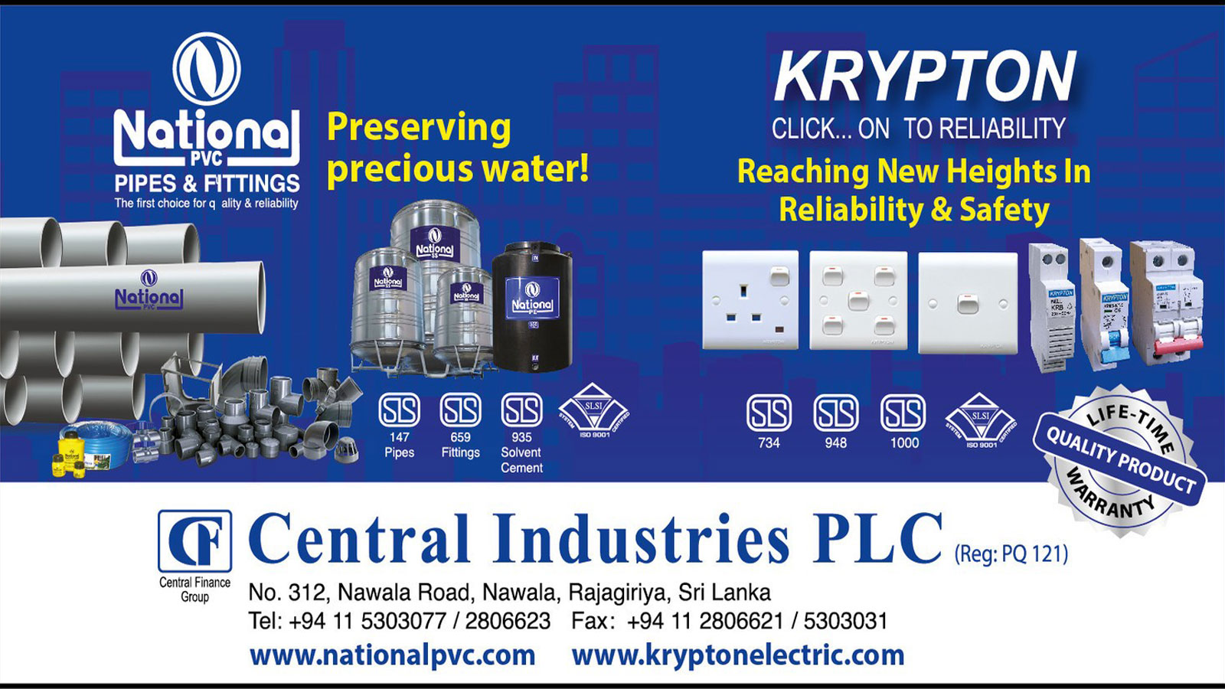

**Established in 1985, Central Industries PLC is a proud member of the highly respected Central Finance group of companies. The company is primarily engaged in the manufacturing and marketing of water management products, as well as switches, sockets, and accessories for electrical installations.Driven by our vision to be the preferred choice of the discerning customer for products and services in the construction industry, they have earned the respect of key stakeholders. Central Industries PLC is widely recognized as one of the most trusted providers of reliable and high-quality products, catering to the needs of both domestic users and large-scale infrastructure projects.**

**National PVC**

As Sri Lanka’s most awarded PVC brand, the comprehensive portfolio of National PVC, meeting international standards consists of PVC pipes, fittings, drainage, irrigational, sewerage, rain water and roofing accessories, flexible hoses, garden hoses, PE and Stainless Steel water storage tanks, septic tanks, conduits and solvent cement for a wide range of industries and applications.

**Krypton**

Renowned as a safe and reliable brand of electrical s witches, sockets and accessories, Krypton is a leading brand in Sri Lanka, manufactured by Central Industries. Trusted by professionals for both simple domestic requirements and complex projects, Krypton product portfolio caters to a wide range of applications.

**3. Nature of the Business**

There are 4 sales representatives who take orders from the respective areas and delivery the goods as per the invoice. The Company has provided 60 days credit period to us and we will give to the customer the same.

|  |  |  |  |
| --- | --- | --- | --- |
|  | National PVC | Krypton | Total |
| Bank Guarantee provision | 12Mil | 3 Mil | 15 Mil |
| Monthly sales target | 8 Mil | 2.5 Mil | 10.5 Mil |
| Profit margin | 8% + 1.5%( when sales target archived) | 12% | 20%+ 1.5% |
| Sales representative (Provide by company) | 1 for Badulla area  1 for Mahiyangana area | 1 for Badulla area  1 for Mahiyangana area | 4 |
|  |  |  |  |

We have to provide the list of below table

|  |  |  |
| --- | --- | --- |
| Delivery Lorry | 01 | Available |
| Warehouse for store goods | 01 | Located at 21st mile post, Baduluoya |
| Manager | 01 | Available |
| Driver | 01 | Available |
| Diver’s assistant | 01 | Available |
| Cash collector | 01 | Available |
| Computer operator | 01 | Available |

**4. Distribution area**

**Mahiyangana Area**

National / Krypton

Badulla Mahiyangana Road, Mahiyangana Town, Girandurukotte, Medagama New Medagama,Dehiattakandiya , Siripura , Kalukele

Hasalaka, Minipe, Hettipola, LaggalaPadiyathalawa Road, Padiyathalawa Town

Andaulpotha Keselpotha, Uraniya, Ridimaliyadda

**Badulla Area**

National / Krypton

Badulla, Bandarawela, Welimada, Haputhale, Diyathalawa, Haldummulla,

Nuwara Eliya Road, Boragas

Passara, Lunugala, Ballaketuwa, Namunukula,Ella

